Decision Tree

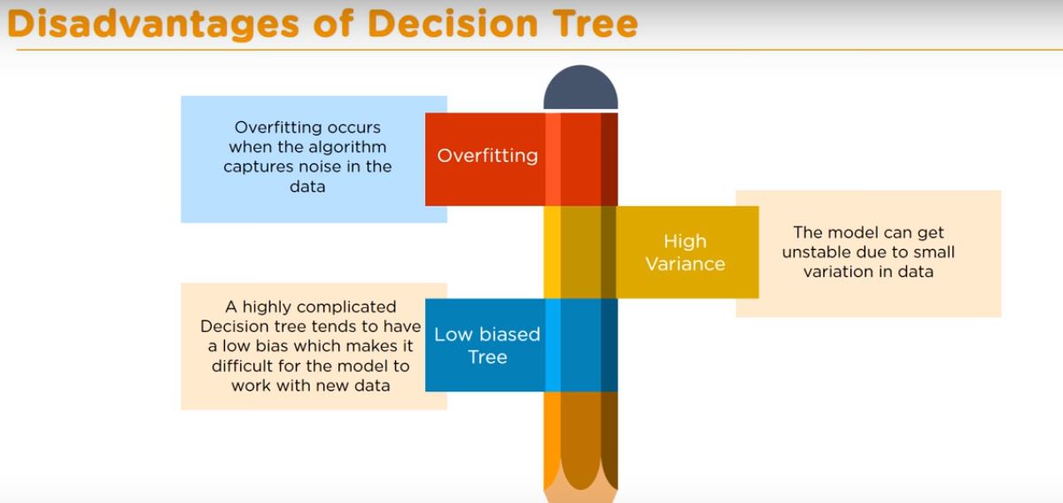

Entropy : Is the measure of randomness or unpredictability in the dataset